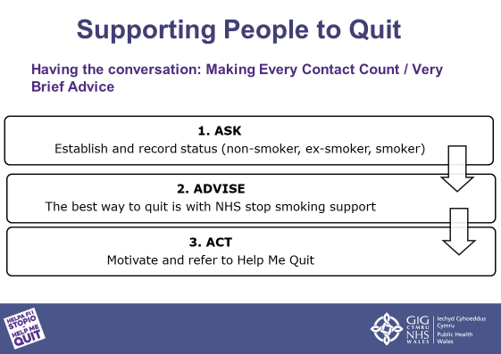

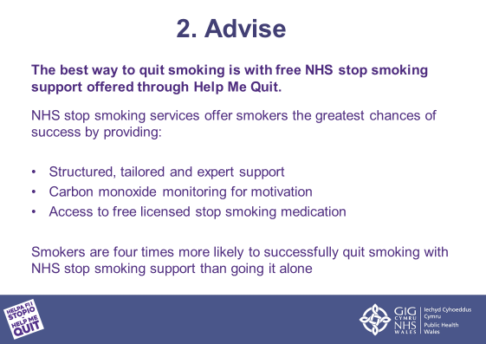
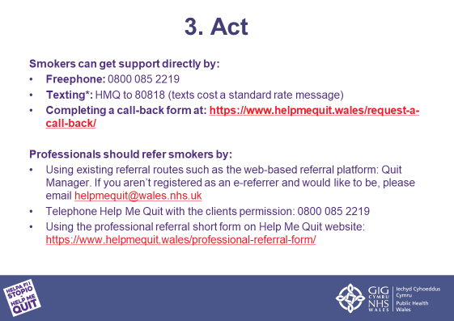
https://www.helpmequit.wales/request-a-call-back/
helpmequit@wales.nhs.uk
https://www.helpmequit.wales/professional-referral-form/

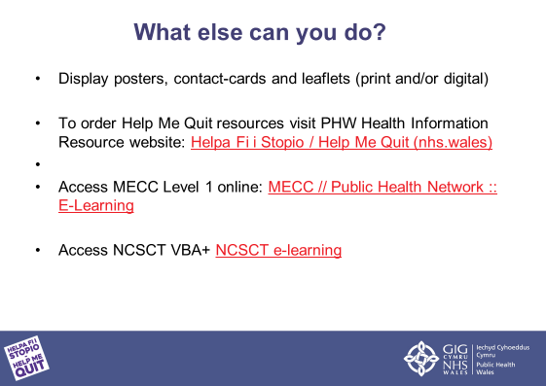
MECC // Public Health Network :: E-Learning
NCSCT e-learning

