Guidance to completing the Ophthalmic Practice Self-Assessment Form

(Mobile Service preparation for WGOS)

PART A | Commentary
3.3 | To provide WGOS as a mobile service, the Contractor must have a Mobile Service Agreement with the Health Board aligned to the location where the service is to be delivered.  You must therefore:  - Be on the Ophthalmic list for the Health Board you are wishing to provide WGOS 1 and 2 (if you are not listed with the Health Board, you will need to apply – information can be found here)  - Send an Ophthalmic Practice Self-assessment form for every Health Board you wish to provide a service.  NB: where you are applying for more than one Health Board, we would encourage you to send in one to begin with. Once one has been approved, then you can then use this as a template for the other applications.
4. | Opening hours: this related to when a patient is able to contact the practice.  NB: prior to the new regulations coming into force, you will be asked to confirm your core hours for every health board, these being the hours you are able to regularly provide a WGOS 1 and WGOS 2.
6.1 | Please provide evidence of how a patient would know that they are eligible for NHS eyecare in your practice. This could include a poster or a link to a page on your website.  The attached are examples of what has been accepted:
6.2 | Please provide evidence of how a patient would know that they are eligible for help towards the cost of their spectacles / contact lenses. (see 6.1 for examples)
6.3 | Please provide evidence of how a patient would be able to identify who you were if you attended their home to provide a mobile service. e.g. a name badge
7.1 & 7.4 | Please provide your policy which must include how a patient that is eligible for an NHS service would be able to escalate their concern to the Health Board if they were dissatisfied with your offer of resolution.  NB: the policy must relate to Health Board in Wales and not NHS England  Details can be found in this poster:
8.1 | Please can you share your certificates as PDFs – these can be sent via email.  Ensure that the certificates are the current certificates and are in date.  Please could you also provide details of your Professional Indemnity Insurance
9.1 | If the practice operates a hybrid record keeping system, please can you indicate what is kept on paper and what is digital?
9.2 | In preparation for NHS Wales emails, you will need to be registered with the ICO.  You can register and download your certificates as PDFs here: Information Commissioner's Office (ICO)
9.3 | Please provide evidence of how your securely store your records:  Paper records: you could include a picture of the filing cabinets and an explanation of where they are located and measures that are in place to limit the risk of patients accessing the records.  Digital records: you could include a picture to demonstrate that a password is required to access patient details
9.4 | This question is for PPV purposes. Please provide images of the appointment record as well as dispensing records.
10.2 | You are required to have an Information Commissioner’s Publication Scheme / Freedom of Information policy.  This template is available on QiO platform and can be adapted to fit your practice:

PART C
1.1 | If you employ anyone, you must either:  - display the health and safety law poster where your workers can easily read it  - provide each worker with the equivalent health and safety law leaflet  The poster explains British health and safety laws and lists what workers and their employers should do.  You can add details of any employee safety representatives or health and safety contacts.  (NB: if you od not employ anyone, this is not required)  You must have the correct poster displayed: New Health and Safety Law Poster April 2014 (esedirect.co.uk)
2.2 | Please note the following which is taken from the WGOS 1 & WGOS 2 Service manual:  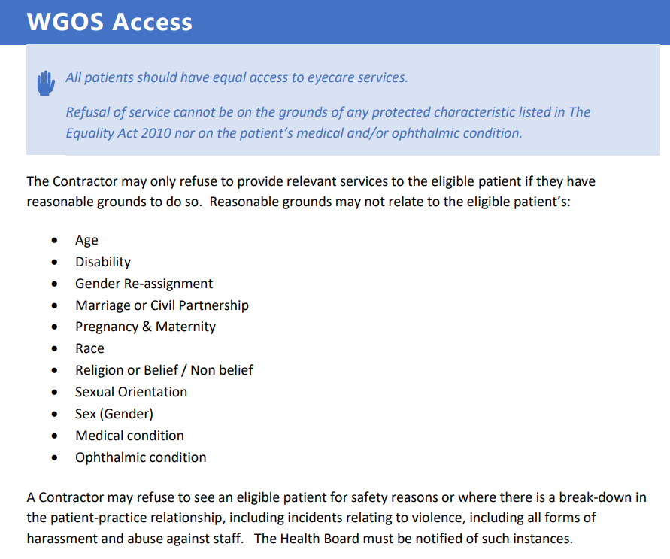
Equipment | As per page 16 and 17 of the WGOS 1 & 2 Service Manual, to be able to provide WGOS 1 & 2 you must be able to access the equipment that has been listed.  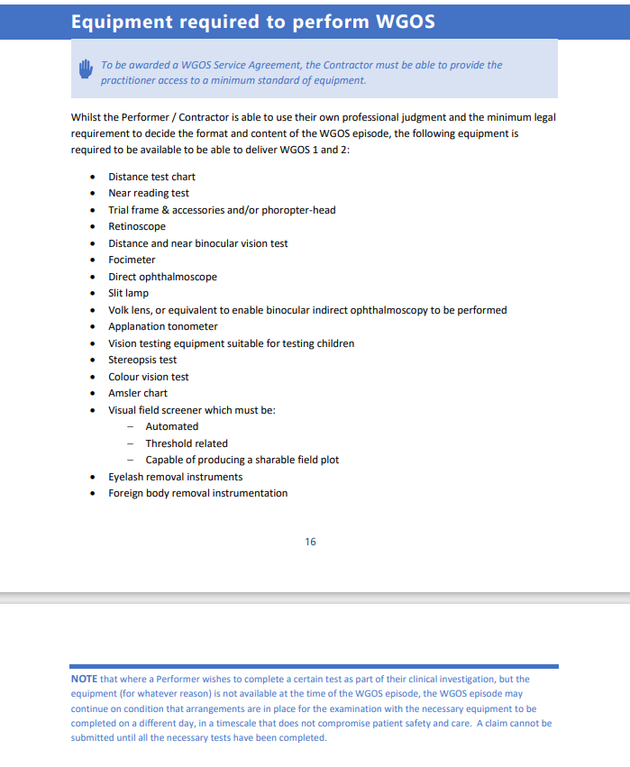  As part of this process, the Health Board need to ensure that you would be able to access the same level of equipment when conducting a mobile service as you would be able to access in a static practice.  Please note for the equipment section, it is picture of the actual portable equipment that you would use during a domi visit that we are required to see and not the ones that are in the Practice. If you don’t have access to some of the equipment that the EHEW service requires a practitioner to have access to, we would encourage you to contact Sharon Beatty at Optometry Wales (SharonBeatty@Optometrywales.com) for assistance in how to access the equipment.  Where an item of equipment is not part of your usual “domi kit” and you would be need to return at a later time / date to complete the test, please can you provide details of:  - how long it would take you to return to the patient  - where the item of equipment is being stored.  Foreign Body removal instrumentation:  Under new regulations you will be providing emergency care.  The following guidance may be helpful for you to decide what equipment you will need to meet the requirement: Corneal (or other superficial ocular) foreign body - College of Optometrists (college-optometrists.org)  NB: The health board will require to see evidence that you have this in place prior to approval.
Ophthalmic Drugs | Please ensure that the form captures:  - the type of ophthalmic drugs you have access to in a mobile setting  - how they are securely stored when not in use (NB: the Health Board need to ensure that these P or POM medications are securely stored and out of reach of children)  - how they are securely transported to the patients  - how they are disposed (College guidance can be found Safe disposal of waste - College of Optometrists (college-optometrists.org)
Declaration | Explanation to why the declaration states that EHEW cannot be delivered in a mobile setting  Current EHEW regulations (these will no longer exist when the new Regulations come into force):  - allow the EHEW service to be delivered from a static premises (i.e. a practice on the high street)  - does not permit EHEW to be delivered in a domiciliary setting  - Static practices have therefore been eligible to be EHEW accredited to complete EHEW from these premises. However, they have not been accredited to deliver EHEW in a domiciliary setting as this has not been permitted.  New regulations will be coming into force on 20 October which stipulate that:  - all Performers (Optoms / OMPs) are required to be able to accredit to a level that is equivalent to the current EHEW standards  - all Contractors (regardless of whether they complete eye examination from a static premises or from a mobile setting) are required to be accredited to a level that is equivalent to the current EHEW standards  How can we mitigate a break in provision of eye care in a domiciliary setting when the new regulations come into force?  - Contractors operating from a static practice that are not yet EHEW accredited have been made aware of the new Regulations and given the opportunity to become EHEW accredited prior to the date the new regulations come into force. If accredited, they may provide EHEW immediately from their static premises as the current regulations permit this.  - Contractors offering a domiciliary service need to evidence that they can meet the current EHEW standards and can deliver the same standards of care as a static practice but in a mobile setting. The form is to be completed to evidence this requirement in preparation of the new regulations coming into force. As the current regulations do not permit EHEW from being completed in a domiciliary setting, even if they meet the EHEW standards, Contractors will not be able to deliver the EHEW service. However, on the date the new regulations come into place, as they have demonstrated and the Health Board has had confirmation the Contractor meets the requirements of the new regulations, they will be able to continue to provide a domiciliary service. NB: there are other requirements that need to be met, not just being up to EHEW standards e.g. HEIW training modules.  In summary the declaration is to confirm that the Contractors are aware that the completion of this process does not permit them to deliver EHEW in a domiciliary setting.

