Y Ty Dysgu – User guide
If you have not already been through the sign up process, click on the icon below .
Once you have signed up and received your email confirmation you can ‘Sign in’ using your email as the username and your chosen password when you signed up.
You will automatically be directed to your dashboard. Here you can view certificates, courses, events etc.
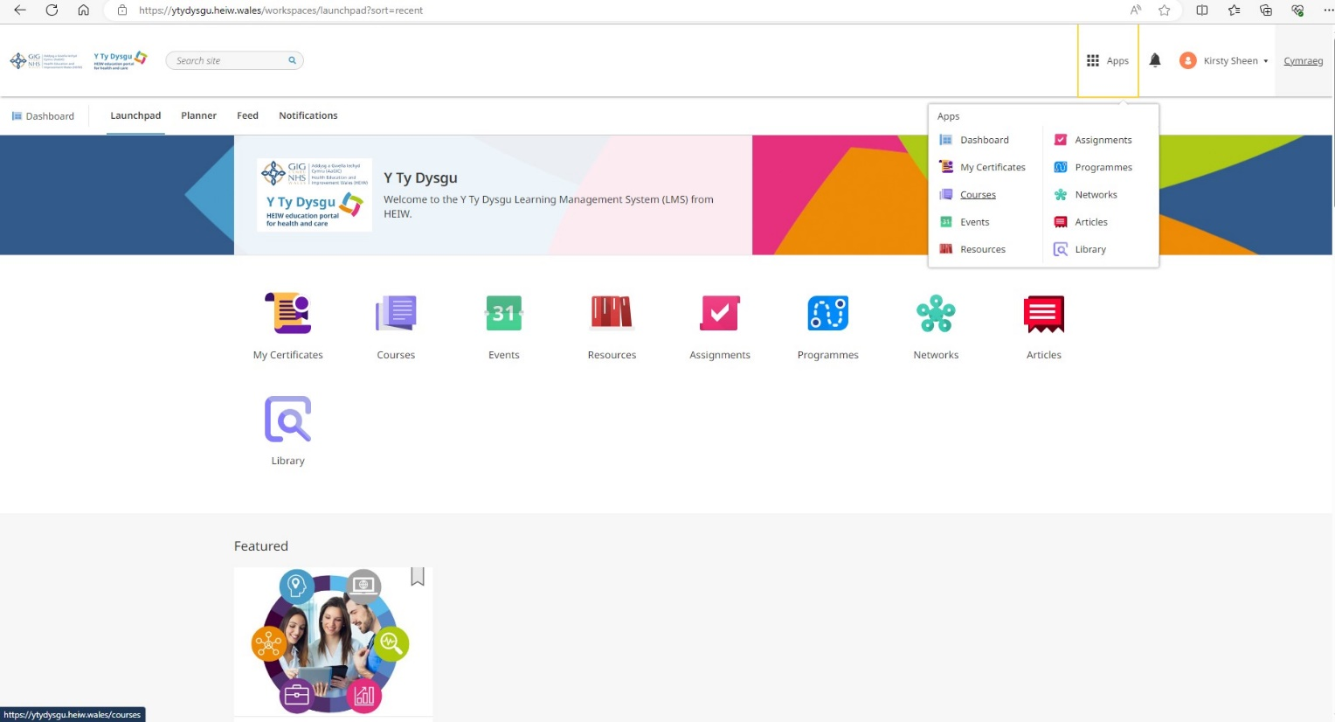
The Apps button is useful to navigate at any time.
Optometry related events (in the future)
Where you view your certificates for CPD purposes when you have completed presentations
Access presentations here
Where you can search for courses using keywords e.g. ‘Optometry’
Where to see the 4 presentations you need to do
View results from MCQs here
Those icons not circled are non WGOS related

You can see your contract reform supporting presentations all in one place by clicking the Programmes app from your Dashboard.
Go to ‘Programmes’
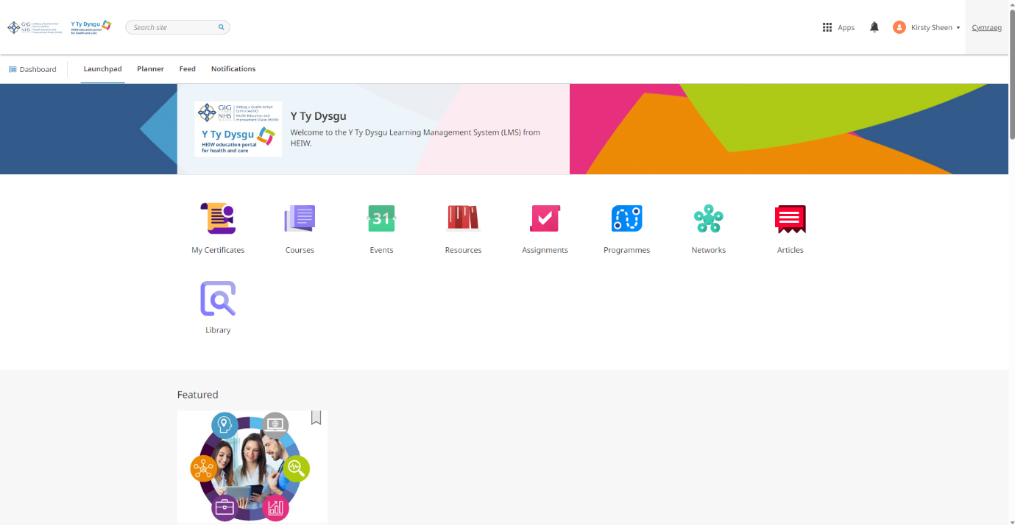

You can now see the WGOS compliance programme which includes the presentations you need, Click on the ‘WGOS Compliance programme’
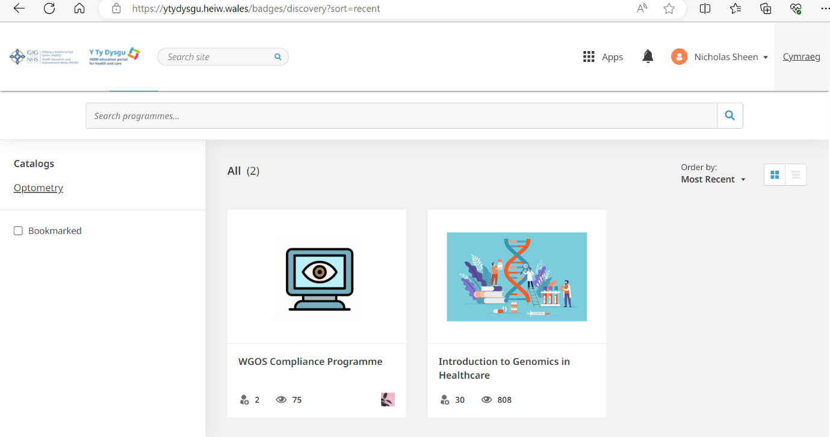

You can now view the 4 presentations to access, after starting the certification, click on each to make a start. E.g. In this example we are going to the Making Every Contact Count course.
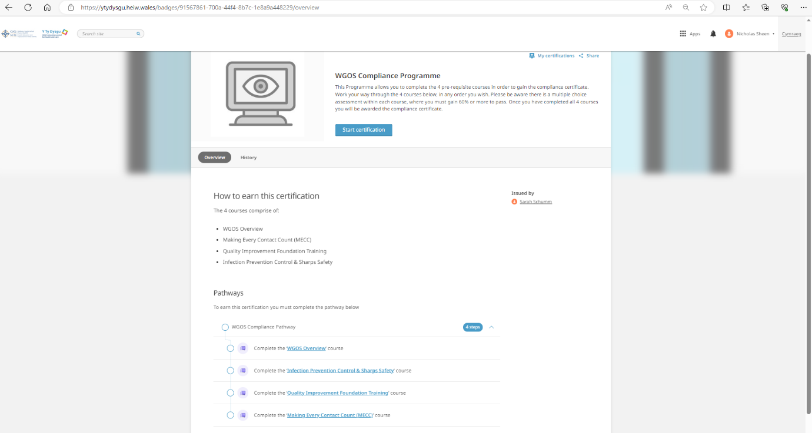

This brings up this page, to access click ‘Go to course’
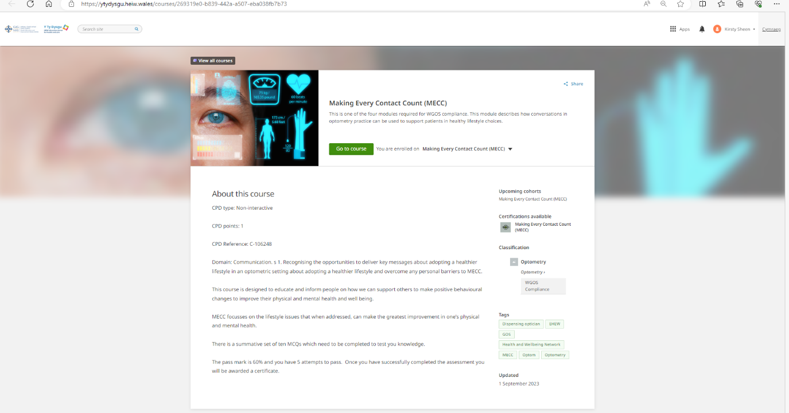

Note that for every course you click on, you will see 4 tiles; Accessibility statement, the MECC course, an evaluation (post course feedback), the MCQ assessment (required to pass the course). To access each, just click.
Click on the ‘Making Every Contact Count Course’ to make a start.
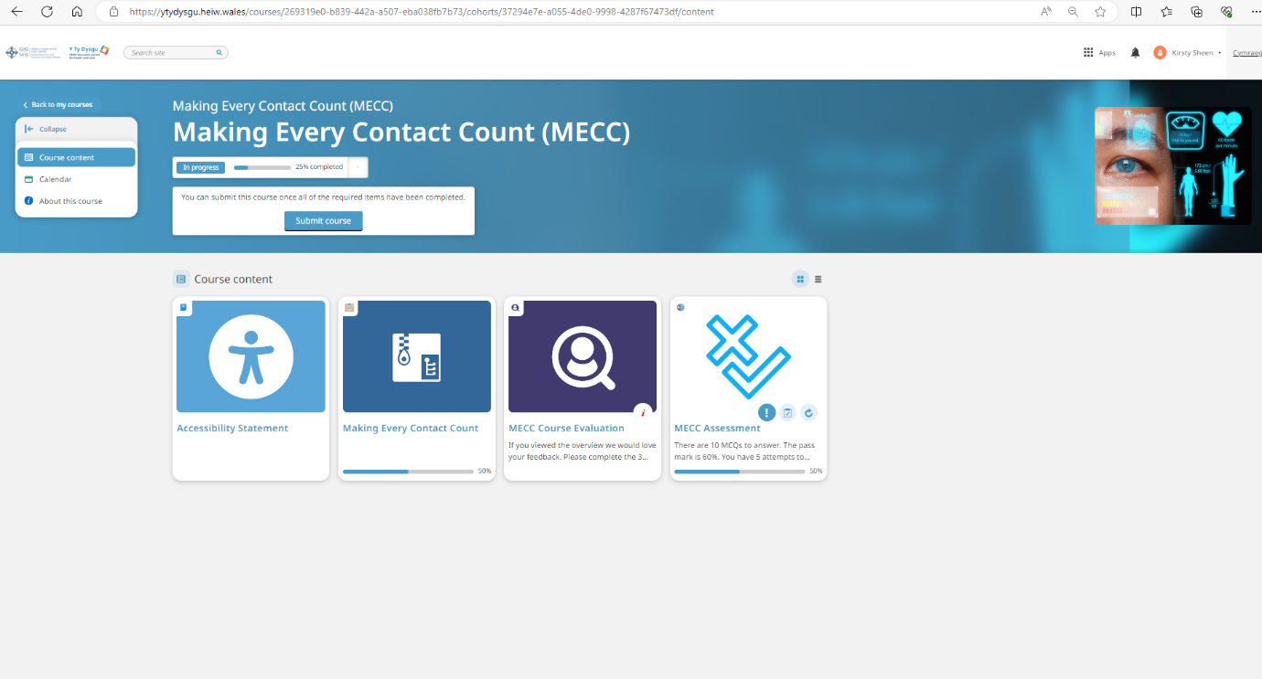
This takes you to the presentation, but first you see this screen.
Click ‘Continue’ when you are ready

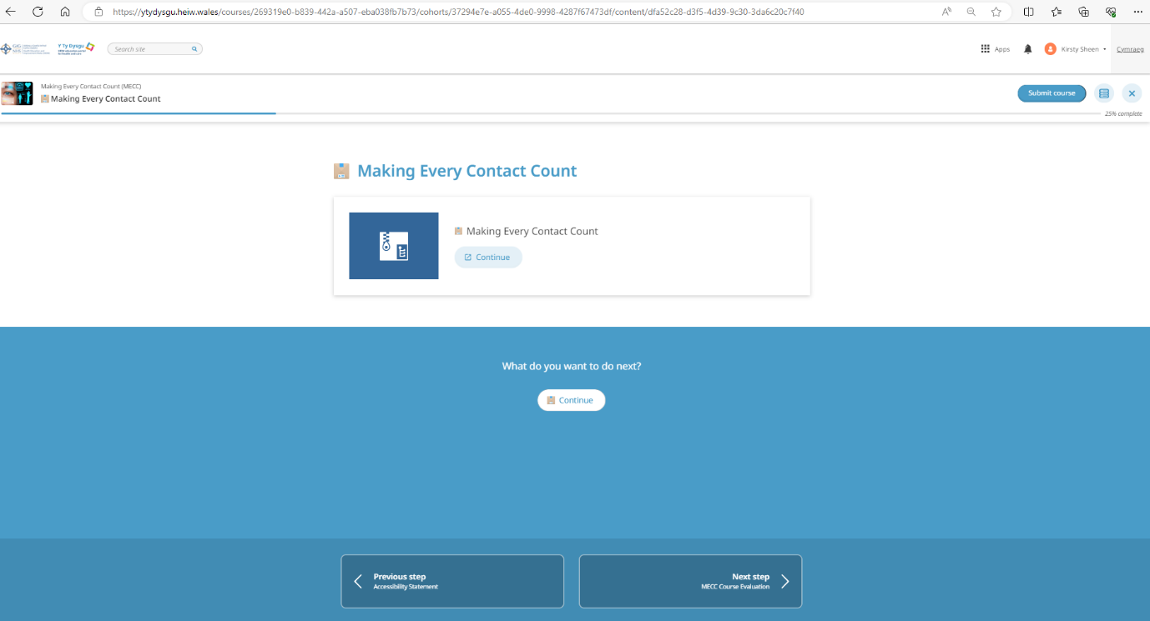
You are now in the presentation.
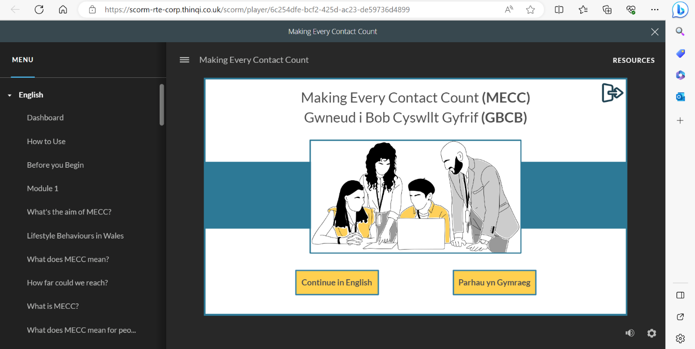

When you finished the course, you can close the window with the ‘X’ in the top right hand corner, you will then see that it is complete – see below.
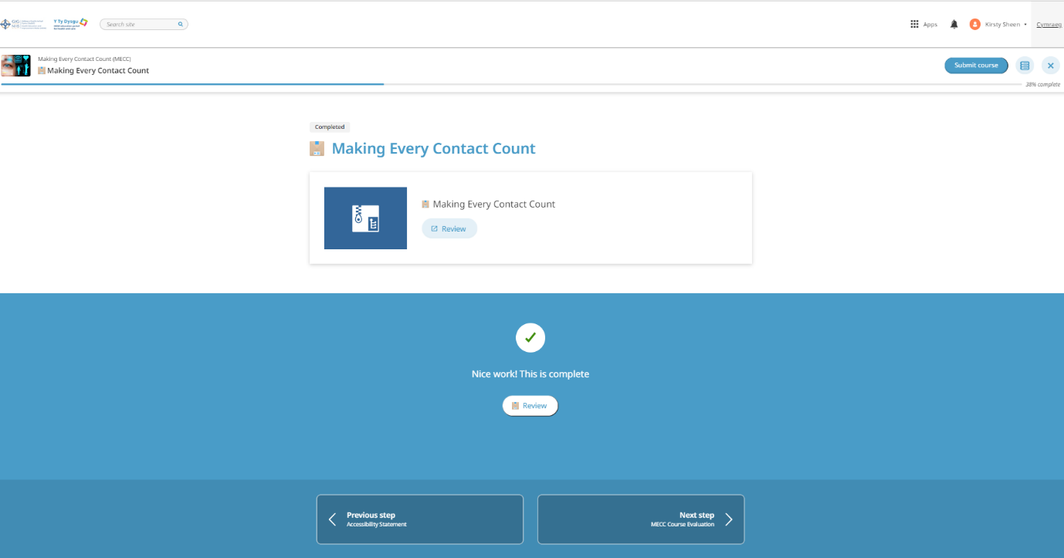

Next step is the course evaluation, where you can give feedback, or you can go to the Next step, ‘MECC assessment’.
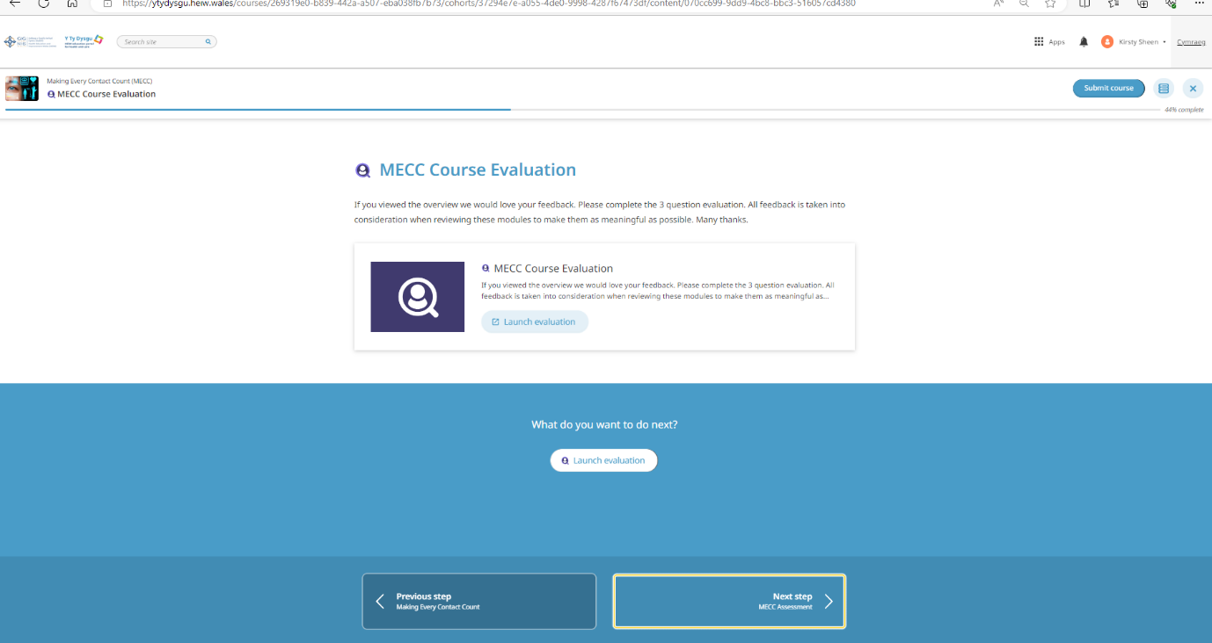

Click on Start assessment and you can begin.
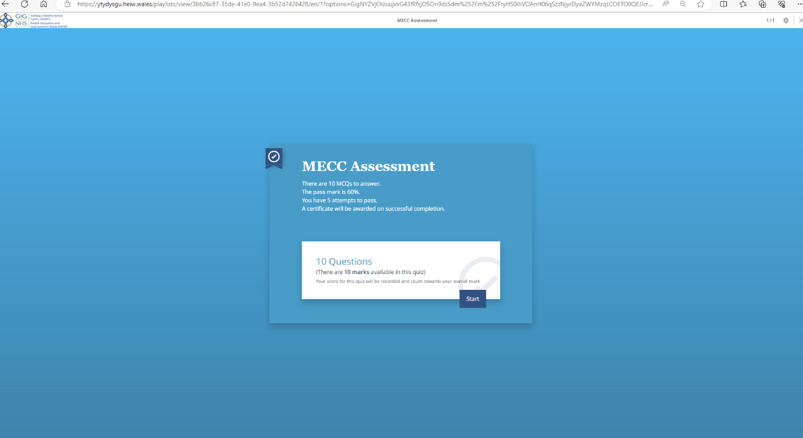

Once you have completed your assessment and scored at least 60% you can submit. You will see a blue button at the top right to submit the course.

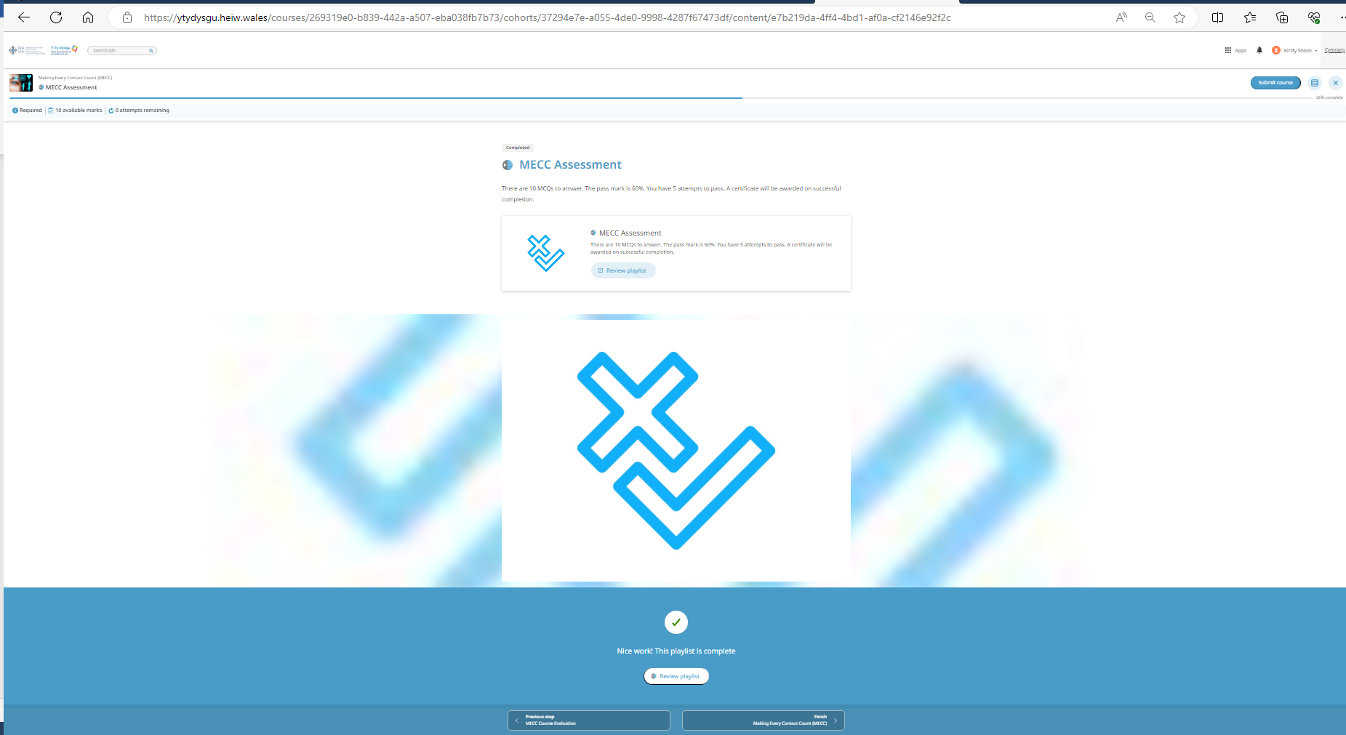
You can submit the course without having to do the evaluation feedback or view accessibility, although you will prompted to view these before final submission -these aren’t mandatory.
Once submitted you can do the next presentation or check your progress. Go back to ‘Programmes’ or ‘Courses’ to see your progress.
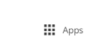
If you have completed the presentations previously but want to look through them again, you can do so by going to Apps and Courses, then ‘My courses’ tab on the top left of the screen (next to Discovery).
Use the Apps button at the top right hand side to navigate at any time.

Good luck!

If you have any problems please contact us at HEIW.Optometry@wales.nhs.uk putting ‘YTD’ in the subject header of the email.
Please note HEIW is responsible for the training and education of the workforce, any service queries need to be directed to PCSoptometric.Advisors@wales.nhs.uk.

